ABSTRACT
This report presents a comprehensive network analysis of the film industry, aiming to show insights on prominent actors and trends in ratings and votes within the film industry over the decades. The findings provide insights into the structure and interconnectedness of actors in the industry, which helps to understand how the film industry networks. It also highlights the influence of the digital age (2000s) on ratings and voting patterns.

INTRODUCTION AND BACKGROUND
Network analysis is a method for studying the structure and relationships between entities, or nodes, and the connections between them, or edges. It can be used to uncover patterns, identify central nodes, and understand the overall structure of a network (Khemka et al., 2024). It can be applied in public health, social interactions, and in management and conservation.
The film industry thrives on actor collaborations and viewer engagement metrics, such as ratings and votes. Network analysis in the film industry can be used to find out actors who are in the center of the movie universe, patterns in viewers’ ratings, and voting preferences (Rhyd, 2023). By constructing a network that connects actors through shared films, this analysis seeks to uncover patterns involving influential actors and film popularity over time-based on centrality and ratings.

DATA COLLECTION
This analysis was conducted using a dataset obtained from Kaggle which contains the following columns:
- Actor: Name of the actor.
- ActorID: Unique identifier for each actor.
- Film: Title of the film.
- Year: Release year of the film.
- Votes: Number of votes received by the film.
- Rating: Average rating of the film.
- FilmID: Unique identifier for each film.
Network
The network was constructed using NetworkX, a Python package for the creation, manipulation, and study of the structure, dynamics, and functions of complex networks. It provides classes for graphs that allow multiple edges between any pair of nodes (NetworkX Developers, n.d.).

Nodes and Edges
In network analysis, nodes represent entities such as people, and companies, and edges represent the relationships between these nodes. Each node in this network corresponds to an individual actor or film, while the edges represent the relationship between them such as appearing in a movie together (Rhyd, 2023).
The network has 54,079 nodes and 191,873 edges which are relatively large and dense, showing that many actors have worked in multiple films together.
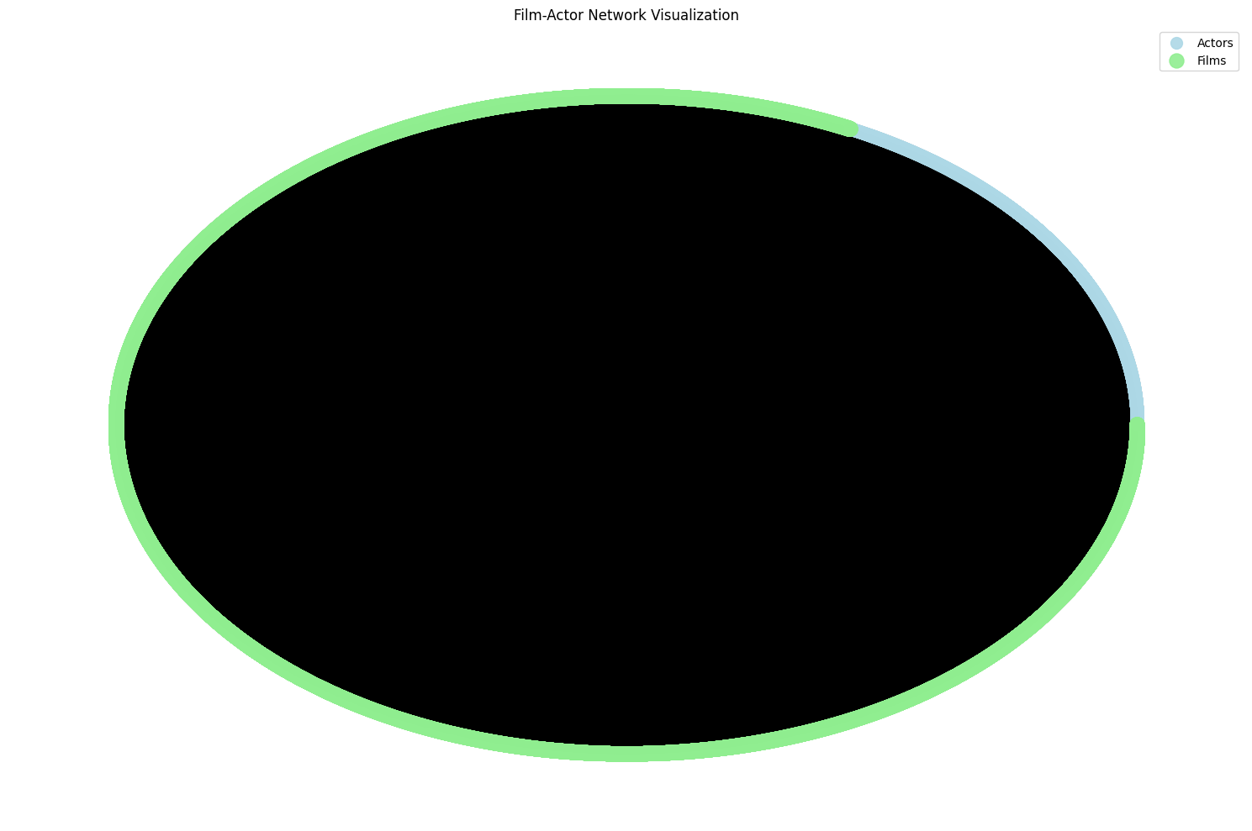
This network visualization in a circular mode shows the two-mode network of actors and films. The nodes in light blue represent the actors while the light green represent the films. Since this is a bipartite graph, each connection or edge exists only between an actor and a film, not directly between two actors or two films. Due to the large number of nodes and edges and high interconnectedness, the circular layout gives a dense appearance.

ANALYSIS
Centrality Analysis
The top 10 actors by number of films include notable names like Anupam Ker, Eric Roberts, and Amitabh Bachchan.
The top 10 actors by betweenness centrality used for centrality analysis include Anupam Ker, Amitabh Bachchan, Christopher Lee, John Carradine, and Eric Roberts who have all had prolific careers, highlighting their roles as top connectors in the industry. Their collaborations extend to other actors across genres, film industries, and regions, making them pivotal in the network structure.

Correlation Analysis
From the network analysis conducted, the correlation between ratings and votes is 0.39 suggesting a minimal positive relationship between them. This implies that films with higher ratings tend to have more votes, however, the relationship is not very strong. While there may be some association between the two variables, other factors that influence the number of votes a film receives may include genre, popularity, and marketing (Hao, 2023).

Time-based Analysis
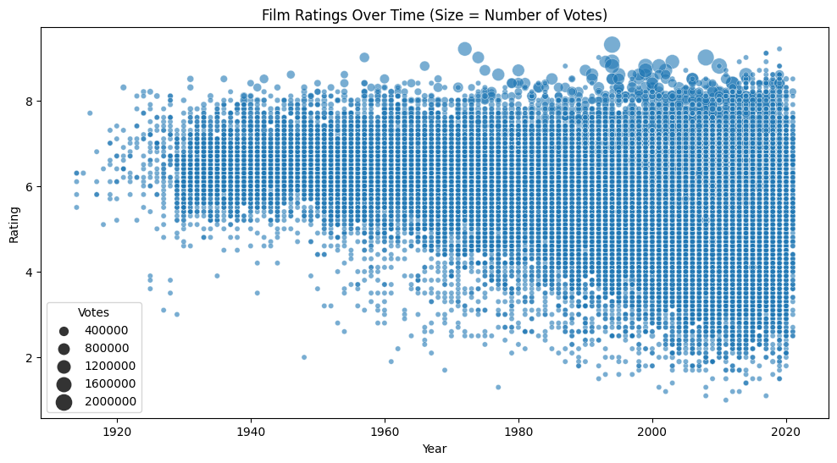
From 1914 to 2021, there has been a general increase in the number of votes and ratings, with ratings generally between 5 and 8 and high density around 6 and 7, suggesting that most films receive moderate to good ratings. The number of votes for films increased in the 2000s, which could be due to several reasons, including increased availability of online platforms where viewers could vote and social media awareness. There was also an increase in movies receiving 8+ ratings after 2000.

Conclusion
This network analysis of collaborations within the film industry provides insights into actors’ influence, collaborative communities, and viewer engagement trends within the industry. Findings highlight prominent actors, and evolving trends in film ratings over the decades, contributing to a better understanding of the complex interplay of collaborations, popularity, and digital age influence in the industry.

REFERENCE
- Hao B. (2023). The Analysis of the Factors that Influence the Film Revenue. Highlights in Science, Engineering and Technology 47:154-159. http://dx.doi.org/10.54097/hset.v47i.8184
- Khemka A., Harvey S., Vo V., Kantoro K.A., Jones P. (2024, August 11). Leading by the nodes: A Survey of Film Industry Network Analysis and Datasets. Arxiv. https://arxiv.org/html/2408.06393v1
- NetworkX Developers. (n.d.). NetworkX tutorial. Retrieved October 29, 2024, from https://networkx.org/documentation/stable/tutorial.html
- Rhyd Lewis (2020, Febraury 23). What Social Network Analysis Tells Us About the Film Industry. The Buzz.
https://nationalinterest.org/blog/buzz/what-social-network-analysis-tells-us-about-film-industry-125526

